Accessible Standard Algorithms for Understanding and Equity Part 2:
Multidigit and Decimal Subtraction, Multiplication, and Division

Professor Emerita Karen C. Fuson
School of Education and Social Policy, Northwestern University
karenfusonmath.net and karenfusonmath.com
Shannon Kiebler
Professional Development Specialist, Empower Consulting
Robyn Decker
Mathematics Professional Development Specialist, UltramathPD Consulting

A standard algorithm uses single-digit operations and concepts of place value (Fuson & Beckmann, 2012/2013; The Common Core Writing Team, 6 March 2015). We discuss standard algorithms for multidigit and decimal subtraction, multiplication, and division that students can understand and carry out easily, and we show student math drawings that facilitate understanding by relating step-by-step to the written steps in the accessible algorithm.

Part 1 of this paper discusses what a standard algorithm is and then focuses on accessible standard algorithms for multidigit addition (Fuson, Kiebler, & Decker, 2024). Part 1 is available on the NCTM website nctm.org. This Part 2 was in the original paper but had to be cut because of length limitations. As background for the accessible standard algorithms in this paper, we start with a figure that shows the math drawings, written method, and explanation of a student doing the most important accessible standard algorithm for multidigit addition. We do this to emphasize that our approach to algorithms is always focused on meanings. Students make math drawings of place-value quantities that relate to their written method. Students explain their methods and then classmates ask questions, leading to productive discussions. More detailed descriptions of the addition accessible standard algorithms can be found in publications on my website karenfusonmath.net or karenfusonmath.com (Fuson, 2020, Fuson & Beckman, 2012/2013, and Fuson & Li, 2014). More detailed discussions of the accessible standard algorithms for multidigit multiplication and division can be found in Fuson (2003a) and Fuson (2003b). The accessible standard algorithms discussed in Part 1 and Part 2 meet the Common Core State Standards (NGA Center and CCSO, 2010) and other high-quality state standards.
Additional resources for understanding the accessible standard algorithms for all four operations can be found in Table 1. All of the students shown in the videos are from Spanish-speaking backgrounds and many are from backgrounds of poverty. They are wearing uniforms because their public school requires them to do so to decrease gang activity.

Table 1
Detailed Explanations of Accessible Standard Algorithms

What to see | Where to go
To watch first graders explaining math drawings and the three multidigit addition standard algorithms in Figure 1 | Please go to https://karenfusonmath.net/classroom-videos/#C-Longer-Classroom-Teaching-Examples and play Grade 1
To watch the first author explaining math drawings and the three multidigit addition standard algorithms along with students from several grades solving problems | Please go to https://karenfusonmath.net/classroom-videos/#B-Math-Explanations and play Multidigit Addition
To watch third graders explain 3-digit subtraction accessible standard algorithms | Please go to https://karenfusonmath.net/classroom-videos/#C-Longer-Classroom-Teaching-Examples and play G3 Multidigit Subtraction.
To watch fifth graders explain 7-digit subtraction accessible standard algorithms | Please go to https://karenfusonmath.net/classroom-videos/#G-Place-Value-and-Multidigit-Addition-and-Subtraction and play the last video G4 Explaining 7-digit subtraction.
To watch fourth graders explaining all three multiplication accessible standard algorithms | Please go to https://karenfusonmath.net/classroom-videos/#C-Longer-Classroom-Teaching-Examples and play the fourth video 4 G4 Multidigit Multiplication.
To watch the first author explaining math drawings and the three multiplication accessible standard algorithms with examples of students using each algorithm | Please go to https://karenfusonmath.net/classroom-videos/#B-Math-Explanations and play Multidigit Multiplication
For a description of extensions of the multidigit accessible standard algorithms to decimals | Please go to https://karenfusonmath.net/teaching-progressions/ and scroll down to Numbers Base Ten, Place Value Parts 4, 5, 6, 7 and read Beckmann and Fuson, April, 2014

An Accessible Standard Algorithm for Multidigit Addition

Figure 1
Math Drawings and Explanation of An Accessible Standard Algorithm for Multidigit Addition
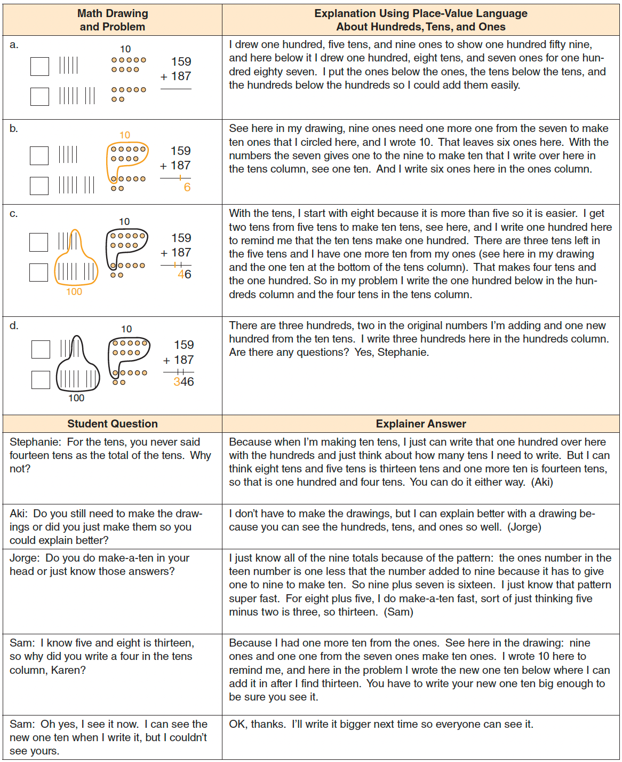 Reprinted with permission from Figure 2.21 in Teaching with Curriculum Focal Points: Focus in Grade 2, copyright 2011 by the National Council of Teachers of Mathematics. All rights reserved.

We also show here the Secret Code Cards shown in Fuson, Kiebler, and Decker, 2024, because these important conceptual supports help students to understand place-value notation in the algorithms there and here in Part 2. Pages of the Secret Code Cards and directions to make them are on karenfusonmath.net or karenfusonmath.com in the file How to make Secret Code Cards to show place-value numerals on the Math Expressions Users page. A page of ten-structured dots and directions for helping students to make math drawings for multidigit addition and subtraction are on karenfusonmath.net or karenfusonmath.com in the file How to make math drawings for hundreds, tens, and ones on the Math Expressions Users page. This page of the website also contains directions to use both of these learning supports to understand place-value notation and to compare 2-digit and 3-digit numbers (see Comparing multidigit numbers using math drawings and Secret Code Cards) and to add and subtract multidigit numbers (see Adding and subtracting numbers using math drawings and Secret Code Cards).

Figure 2
Secret-Code Cards Layer and Unlayer to Connect Single Digits to Place-Value Expanded Notation.
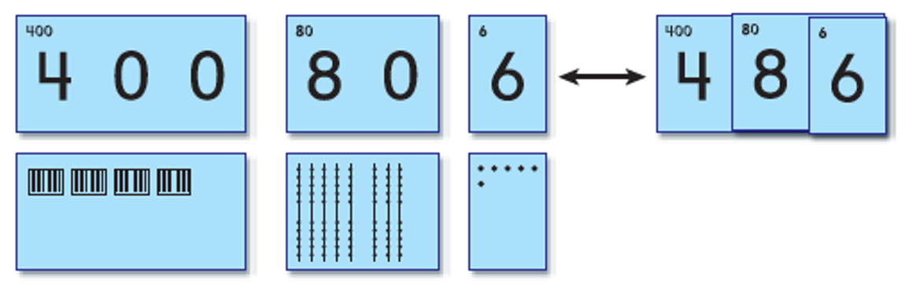
From Math Expressions, Common Core. Copyright © by Houghton Mifflin Harcourt Publishing Company. Available by permission of the Publisher. All rights reserved.

Accessible Standard Algorithms for Multidigit Subtraction

The accessible standard algorithms for multidigit subtraction are shown in the middle of Figure 3 below. The common standard algorithm is shown on the right, and a math drawing that can direct all of the methods is shown on the left.

Figure 3
Multidigit Subtraction Math Drawings, Two Accessible Standard Algorithms, and a Common Standard Algorithm That Is Flawed

Drawn Quantity Model | Accessible Standard Algorithms | Common

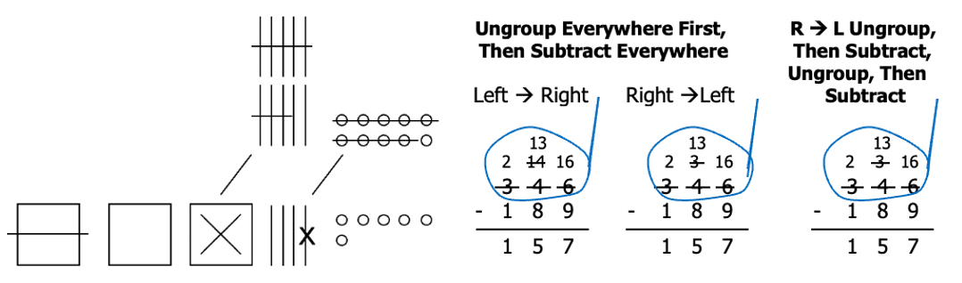
The common standard algorithm shown on the right alternates the two main operations: students ungroup if needed, then subtract, then ungroup if needed, then subtract, etc. This alternating leads students to make errors. As shown in Figure 4, after ungrouping and subtracting in the ones column, the student moves to the next left column. The student is in subtract mode, sees 5 and 3, subtracts to get 2, and writes 2, which is wrong. The answer should be 8 from 13 – 5 = 8. The student knows how to ungroup and has just done so in the ones column. So the alternating steps require an that the student must be super aware of checking to see if ungrouping to get more in a given column is needed and do so for each new column.
The error of subtracting a smaller top number from a larger bottom number is very frequent and can be difficult to overcome. That is why we devised the initial step shown in Figure 3 of drawing a big loop around the top number and having students write the ungrouping within that loop. They draw a little stick to that loop and call the whole thing a magnifying glass that reminds them to check whether every column has a top number bigger than or as big as the bottom number so that they can subtract. This loop also serves as a conceptual reminder that is discussed by students: The ungrouping does not change the value of the top multidigit number but just rewrites it in an equivalent form. The loop also serves to highlight the total as the starting point for subtraction and so the math drawing only shows this total. Subtraction can be done by drawing the total and the known addend and then matching to find how many more the total has than the known addend. But this approach gets messy, and we found that students using it confused subtraction with addition.

Figure 4
The Error Created by the Common Standard Algorithm Because of Its Alternating Steps
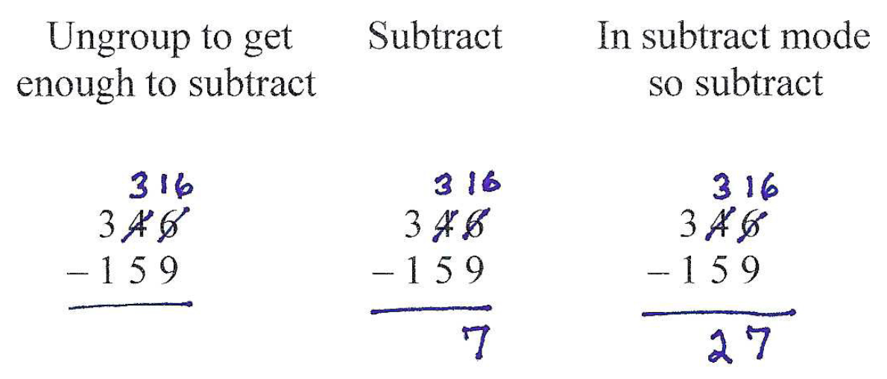
The subtraction accessible standard algorithms are variations of each other in which a student ungroups from the left or from the right. Students do any needed ungrouping first and then do all of the subtracting. Ungrouping from the left may be unfamiliar, so Figure 4 shows the steps in such ungrouping, along with the math drawings that support it and the explanation by the student using this accessible standard algorithm. For both the left-to-right and the right-to-left Ungroup Everywhere First as Needed, Then Subtract Everywhere accessible standard algorithms, students can subtract from the left or from the right after they have ungrouped. Some students like to vary how they solve.

Figure 5
Math Drawings and Student Explanation of the Accessible Multidigit Subtraction Standard Algorithm Ungroup Everywhere First as Needed, Then Subtract Everywhere

[Figure begins on the next page.]
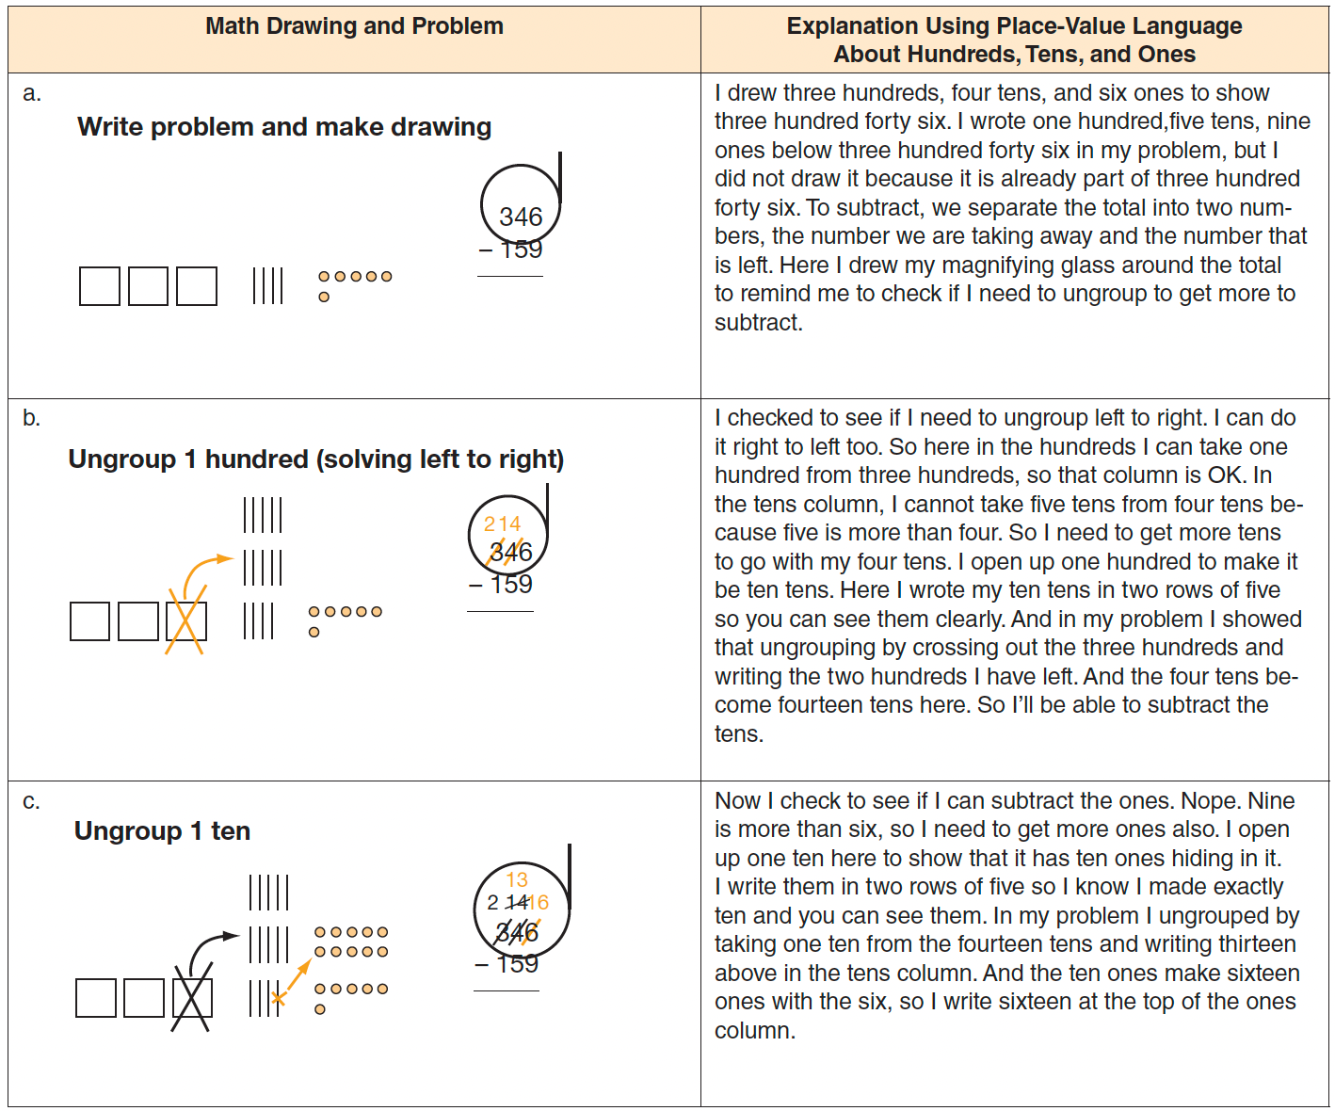
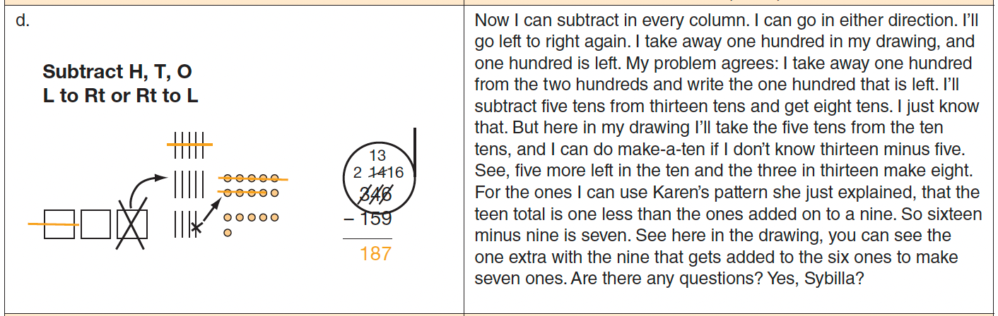
[Figure 5 is continued on the next page.]
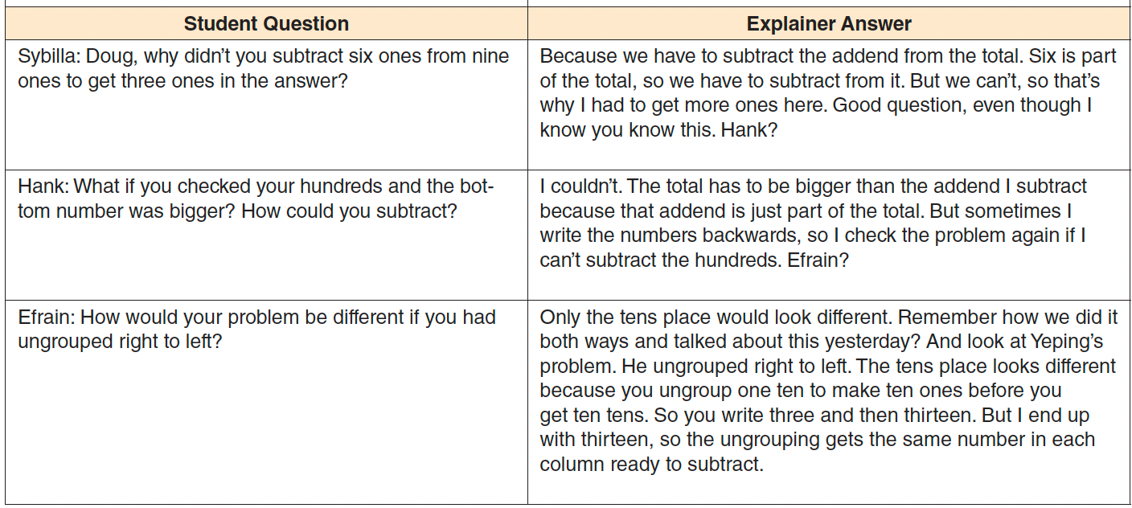 Reprinted with permission from Figure 2.22 in Teaching with Curriculum Focal Points: Focus in Grade 2, copyright 2011 by the National Council of Teachers of Mathematics. All rights reserved.

These accessible standard algorithms do not alternate the two main aspects of multidigit subtracting: ungrouping where needed to get enough to subtract and actually subtracting in a given place value. They also can be done from the left, which many students prefer. These are two of the criteria that indicate that an algorithm is accessible and should be taught (Fuson and Beckmann, 2012/13; Fuson, Kiebler, & Decker, 2024; Fuson and Li, 2014). The common standard algorithm has neither of these positive attributes.
One common subtraction algorithm that comes from some countries in Latin American and Europe is particularly tricky (see Figure 6) and can become confused with the common subtraction algorithm (Ron, 1998). We have been in classrooms where it took parts of two classes to understand and explain this tricky algorithm that may come from homes of students. In our experiences neither parents nor teachers understood why steps were done; they had just learned how to do those steps. See Ron (1998) in the Publications page on karenfusonmath.net or karenfusonmath.com for more discussion of how this method works and how students do a mixed erroneous method that uses parts of this method and of the common standard algorithm.

Figure 6 The European/Latino algorithm add ten to both numbers
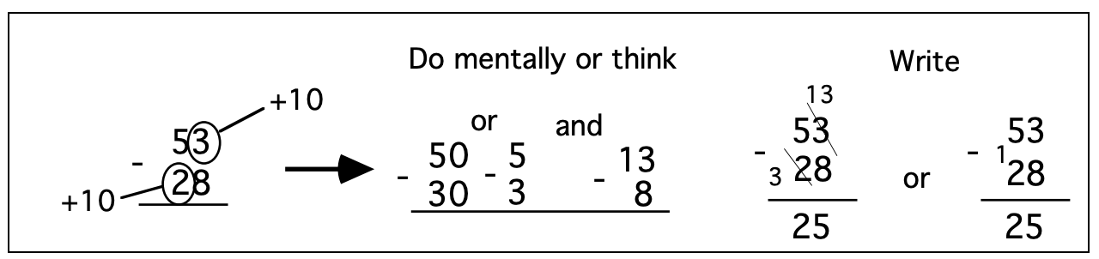
Accessible Standard Algorithms for Multidigit Multiplication

Array and area models are used in Grade 3 to show multiplication of single-digit numbers. In Grade 4 these models can be extended to show multidigit multiplication and how place values of ones, tens, and hundreds work in multiplication. An outline of major aspects of this approach are shown here. Students can work on dot paper with the dots very close together; we use lengths between dots of 4 mm. You do not need much of the dot paper because students will soon be making sketch models of multiplication problems on plain paper and relating these models to written methods.

First, students draw an area to show ones times ones. They draw the area model and then draw in the squares to show the area. Students can draw arrays or area. We suggest using area throughout because area is more difficult for students and this will give them a lot of experience with imagining the squares that make the area. It is helpful for students to write the lengths on all four sides of the rectangle to see all of the relationships involved with larger numbers.

Figure 7
Area drawings for single-digit multiplications
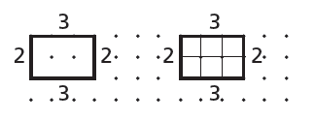

Next students draw an area model for ones times tens. They draw multiple copies of that area model and then explore and find relationships within that area model. Below are shown three patterns that are important for students to see and discuss. The third model is the crucial model because it shows the pattern ones times tens makes a tens product. The unit being counted here is a 1 x 10 rectangle.

Figure 8
Patterns in area drawings for ones times tens multiplications
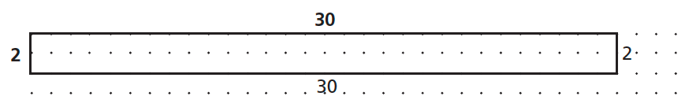

- Divide the rectangle across to show 2 groups of 30.
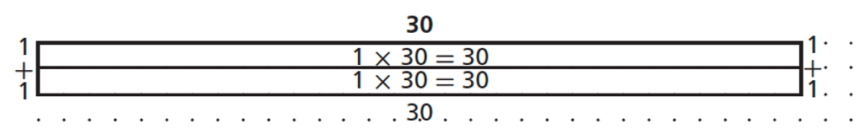

- Divide the rectangle up-and-down to show 3 groups of 20.
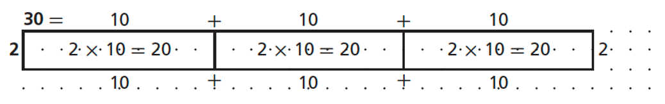

- Divide the rectangle both across and up-and-down to show 6 groups of 10. (Students need only label one of the inner rectangles.)

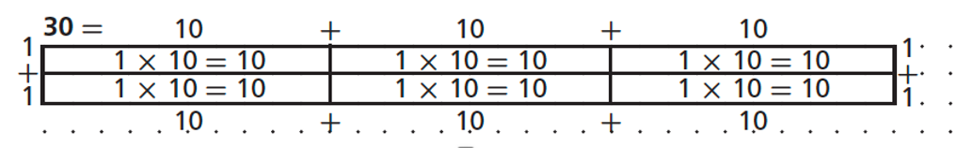

Next students need to explore the tens times tens case to see that they can make units of 100 and they get as many hundreds units as are made by the products of the digits in the tens places.

Figure 9
Units and patterns in area drawings for tens times tens multiplications

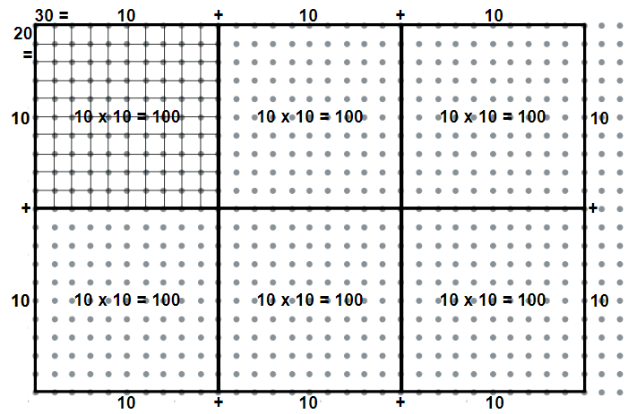

The next step is for students to discuss the patterns they see in multiplying ones times ones, ones times tens, and tens times tens. These patterns can be combined into a table and discussed. The patterns are easy because the product has as many zeroes as are in the factors. This is because each zero in the multiplying factor moves the multiplied factor one place to the left as it is multiplied by ten for the place in which each zero is. Students do need to discuss the special case of multiplying by five because it seems to violate the patterns they have just found. But this is because five times any even number ends in zero, so that adds an extra zero to the product of the places. Students can discuss how they can move from column B to column C by using the associative and commutative properties.

Table 2
Patterns in multiplications involving zeroes

Table 1
A | B | C | D
2 x 3 | 2 x 1 x 3 x 1 | 6 x 1 | 6
2 x 30 | 2 x 1 x 3 x 10 | 6 x 10 | 60
20 x 30 | 2 x 10 x 3 x 10 | 6 x 100 | 600

Most students rather quickly can move from drawing on the dot paper to making sketches on plain paper or dry erase boards in which they show the tens and the ones lengths in the factors and find the products inside each part of the area model (See Figure 10). Students can then write the totals out at the side and add them to find the total area as shown below on the right of the drawing. Because the goal of drawing a model is to stimulate a written method that makes sense as it is related to the model, students need to try writing a written method and explain and justify it by relating it to the model. Shown in the second row of Figure 10 is the Expanded Notation method developed by students so that they understand fully what they are doing. The expanded notation of 28 at the top right and the factors listed on the bottom left in blue are included initially because some students need to see these to do the correct multiplications. These steps can be dropped when students no longer need those steps, resulting in the Partial Products method. These methods are all standard algorithms because they meet the definition of using multiplication of single digits and meanings of place value.

Figure 10
Area drawings and accessible standard algorithms for ones times tens multiplications

Area Model Accessible Standard Algorithms
Place Value Sections
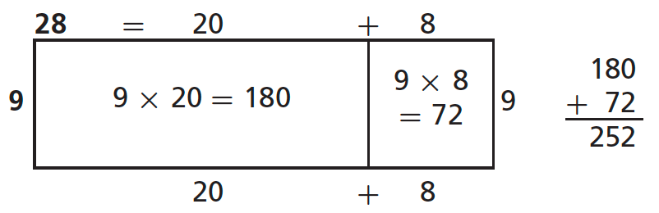

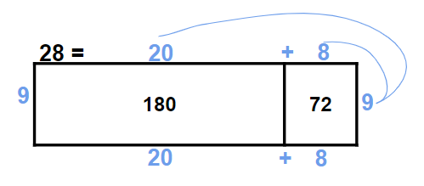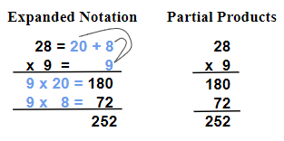

Area models to show multiplications of 2-digit times 2-digit numbers have two rows as shown in Figure 11. Initially students find it helpful to write the factors as well as the products inside the sections of the area model. But as shown in the second area model, many students soon can write the product without needing to write the factors inside the place value sections. Some students then find the product by writing the products of the place value sections out to the right and adding them. Some students do this below the written problem as shown in Figure 11. Many students can go on to the Expanded Notation and other methods shown below. But some students find the layout in all of the written methods below so difficult that they can only be accurate if they draw a quick area model, write partial products inside, and then write the totals out to the side and add them as in the Place Value Sections method.
The Expanded Notation method in Figure 11 was developed by students so that they understand fully what they are doing. The expanded notations of 43 and 67 at the top right and the factors listed on the bottom left in blue are included initially because some students need to see these to do the correct multiplications. These steps can be dropped when students no longer need those steps, resulting in the Partial Products method. These methods are all standard algorithms because they meet the definition of using multiplication of single digits and meanings of place value.
More difficult methods are showed in the bottom row of Figure 11. In these methods the top number in the area model and in the written methods is kept as a 2-digit number and only the multiplying number, here 67, is separated into its tens and ones. So the area model and the written methods all just have two rows. We call all of these standard algorithms difficult because they involve collapsed place value sections. We use the New Groups Below addition method for adding because it is the easiest addition accessible standard algorithm. The non-alternating New Groups Below multiplication method shown first is easier than the other methods because one does all multiplications first and then all additions. Also, in the written method you can see each product 7×3 = 21 and 7×4 = 28 and 6×3 = 18 and 6×4 = 24. In the other two difficult alternating methods one multiplies one place then multiplies the next place and adds in any part of the first partial product that was more than one digit. These methods are more confusing because you cannot see all of the partial products and what has been added is not so clear (such confusing digits are in red). In the final method the 1 at the very top is written in the tens place but it is actually a 1 hundred coming from the 60×3 = 180. We see no reason to introduce the difficult alternating methods to students. The expanded notation or partial products methods seem clear and sufficient for students. And for those students who need to draw the area model sketch to find the partial products, it seems much better to let them do so because it supports understanding as well as correct answers.

Figure 11
Area drawings and accessible standard algorithms for tens times tens multiplications

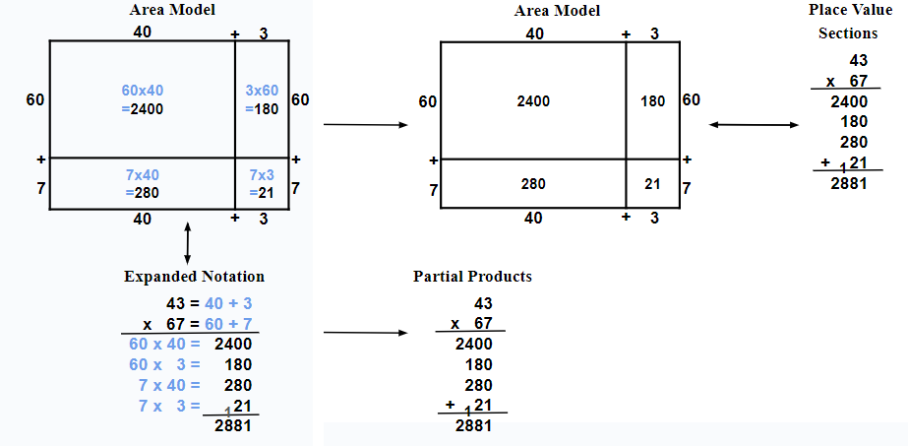

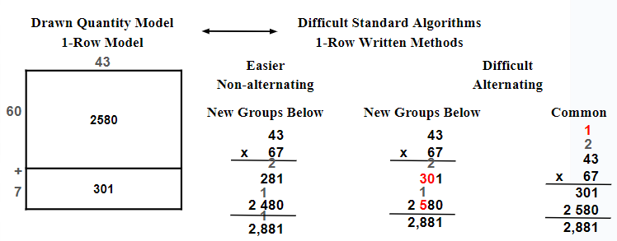

Please see Table 1 for places to find more details of these multidigit multiplication methods and their area drawings.

Accessible Standard Algorithms for Multidigit Division

Figure 12
Multidigit Division Math Drawings, Two Accessible Standard Algorithms, and a Common Standard Algorithm That Is Flawed

Drawn Quantity Model | Accessible Standard Algorithms | Common
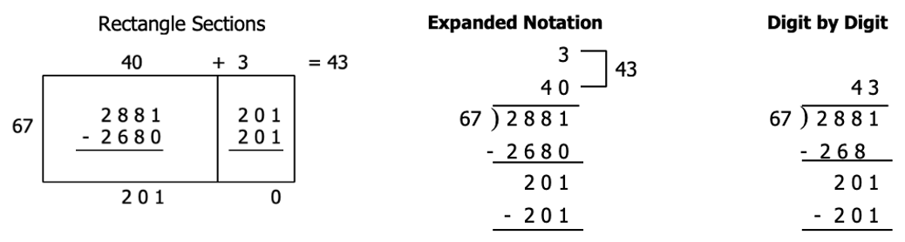
It is important for understanding division that it be related to multiplication. This can be done by using the multiplication area drawing for division but adapting the area model to find the unknown factor that is the length of the rectangle (see Rectangle Sections in Figure 12) rather than finding the area as in multiplication. The two rows in multiplication are collapsed into one row to show the known factor as the divisor, here 67. The multiplying factors for each place value that will make the unknown factor are written above the area model and are added at the end to find the unknown factor, the answer for division. Partial products are written inside each rectangle section in turn, then subtracted from the amount left at that time and the difference is written below the area model and then inside the next section of the area model to show how much area is still available for the next unknown factor length. Rectangle Sections is both a drawn quantity model and an accessible standard algorithm. It is easier for some students because it organizes the partial products they are subtracting in a sensible way.
The other standard algorithms for division shown in Figure 12 use the common long division format in which the rectangle sections are below each other. These formats lose the sense of division as using the area of a rectangle although the area model still can help with making sense of the steps in these algorithms. The common digit-by-digit standard algorithm does not show the place values involved in the steps, so it is too often developed without understanding. It is so easy to write the places using zeroes within the long division format as in the Expanded Notation method that it seems better for students to do that, at least initially, so that they can think about and discuss the place values involved.
The two accessible standard algorithms for division support and use place value correctly, whereas the common standard algorithm only uses single-digit concepts and notation and will only be correct if students align places correctly. All three standard algorithms are done from the left, finding the largest partial product first and subtracting it. All three standard algorithms also alternate multiplying and subtracting so that the amount left for the next partial product is clear. We found that some students could not deal with the spatial-visual demands of simultaneously multiplying and aligning that partial product below the total so far. We suggested that such students write the multiplication out at the side and then write that partial product within their chosen long division format.
In working with students in many classrooms we found that multidigit multiplication and division were similar in that the common format for recording the steps in multiplication or division were too complex for some students to follow. Such students did understand the area model and could enter partial products into the area model and then find the unknown product or the unknown factor. So these accessible standard algorithms Place Value Sections and Rectangle Sections introduced meaningful formats that gave some students success that was not possible with the common written formats.

Generalizing Algorithms to How Many Places?

We have seen in many classrooms that extending the addition and subtraction methods to many places is easy. Such an extension shows the generalizability of place value to adjacent places and makes students feel powerful. But extending multiplication to more than 1-digit times 4-digit numbers or 2-digit times 2-digit numbers introduces many more sources of error and adds little to the understanding of the processes involved. Therefore it seems that little will be gained by having students spend time on larger problems, especially when there are many other topics that are worthy of time and attention

Accessible Standard Algorithms at Any Grade
Teachers have told us that students from middle school and even high school have benefitted from discussing and using the accessible standard algorithms instead of the more difficult common standard algorithm. Some teachers approach the addition and subtraction methods by saying that students are going to use their place-value understanding to explain how different computation methods work. Students will make math drawings and connect them to the steps in the new methods in order to explain these new methods. First teachers have students quickly build up meanings for quantities by using a sheet of centimeter dot paper (see How to make math drawings for hundreds, tens, and ones on karenfusonmath.net or karenfusonmath.com on the Math Expressions Users page). On this sheet, students draw columns through ten dots to make ten-sticks. They draw around ten such ten-sticks to make hundred-blocks composed of 100 dots and ten tens. Students then make a math drawing for a 3-digit addition problem using New Groups Below and then for Show All Totals. Students discuss advantages and disadvantages of each method and compare these to the method they use. The goal is not necessarily to get them to change methods but to develop understanding of written methods related to place value. Some students do change their method after such explanations, and many students say that they are more comfortable with computation when they can explain it.

Extending These Accessible Algorithms to Decimals

These addition and subtraction accessible standard algorithms extend easily to decimals (Beckmann & Fuson, 2014, in Presentations and Numbers Base Ten, Place Value Parts 4, 5, 6, 7 in Teaching Progressions, both on karenfusonmath.com and karenfusonmath.net). The approach for addition and subtraction begins discussing how one added or subtracted whole numbers: one added or subtracted like places. So one needs to do the same thing for decimal places: add or subtract tenths to or from tenths, hundredths to or from hundredths, and thousandths to or from thousandths.
One approach for both multiplication and division is to change the multiplier or the divider to a whole number because we know how to multiply and divide by whole numbers. Doing several such examples allows students to reflect on the patterns involved and formulate some general rule. For multiplication we can change the multiplying number to a whole number by multiplying it by ten for each decimal position it has. So for example, you can change 0.276 to a whole number by multiplying it by ten three times (or multiplying by 1,000) because each multiplication by 10 moves 0.276 one place to the left so it finally becomes 276. But such multiplying changes the original problem so one needs to divide the other factor by 10 three times to keep the problem the same. This moves that factor three places to the right (three places smaller). We can see this compensatory process for 0.276 x 3.24 like this:

0.276 x 3.24 = 0.276 x 3.24 x 1 = 0.276 x 3.24 x 1,000 ÷ 1,000
= 0.276 x 1,000 x 3.24 ÷ 1,000 = 276 x 0.00324
Doing this several times can lead to the understanding that one can multiply as if both numbers were whole numbers and then count the total number of decimal places in both factors to find the number of decimal places in the product.
Students also can envision one factor (the 3.24) sitting on a place-value chart and then consider that multiplying by one decimal place (by tenths) will move that factor one place to the right, one place smaller, because students will be taking one-tenth of each number in each place in that factor. The multiplier then becomes a whole number because 0.2 x 3.24 = 2 x 0.1 x 3.24 = 2 x 0.324. More decimal places in the multiplier can be thought of as repeated shifts of the multiplied factor to the right as each number has one-tenth of it taken as many times as there are decimal places in the multiplier. This process makes one factor smaller by moving to the right while the multiplying factor becomes a whole number. The product of these two factors will have as many decimal places as in the shifted multiplied factor, which is the sum of the decimal places in both factors.
Division by a decimal shifts the dividend to the left (it becomes larger) because one is finding how many tenths are in each number in each place in the dividend. This shift takes place for each place in the divisor until the divisor becomes a whole number. These shifts can be marked in the long division format by moving the decimal points to the right, but we found that it was important to continue to have students discuss this process as shifting both numbers to the left, each getting bigger until the divisor is a whole number. Students also like to think of dividing in fraction form: They can see the process of writing the dividend above the divisor and multiplying that fraction by a 1 in a form (10/10 or 100/100 or 1000/1000) that will change the divisor to a whole number. These two methods together help students to understand the division process of both known numbers getting larger the same number of places.
Discussing such strategies for changing a multiplication or division by a decimal into a multiplication or division by a whole number can help students relate and solidify understandings of relationships between whole numbers and decimals. Students also get to see the mathematical process of turning a problem you do not know how to solve into a case that you can solve (multiplying or dividing by a whole number).

Bringing Family Methods into the Classroom

Students can be asked to interview family members about methods they know and then they can bring such methods into the classroom to discuss and explain. It has been our experience that such methods are rarely understood even by teachers who may have learned them (e.g., Ron, 1998) because parents and teachers usually were not taught with any understanding but only taught procedures to be memorized. But if students make math drawings to help them explain these methods and work together, they usually can figure out why a method works. Students also can look for methods on the web and in books and bring them into the classroom. Doing all of these things can change multidigit computation to being an interesting place for thinking rather than being a source of anxiety or boredom.

References

Most references with my name are on my website karenfusonmath.net or karenfusonmath.com
Beckmann, S. & Fuson, K.C. (2014, April 9-12). Meaningful approaches to algorithms for decimals [Conference session]. The Annual Conference of the National Council of Teachers of Mathematics, New Orleans, LA. See Presentations on karenfusonmath.com and karenfusonmath.net.
Fuson, K. C. Developing mathematical power in whole number operations (2003a). In J. Kilpatrick, W. G. Martin, & D. Schifter, (Eds.), A research companion to principles and standards for school mathematics (pp. 68-94). Reston, Va: National Council of Teachers of Mathematics.
Fuson, K. C. (2003b). Toward computational fluency in multidigit multiplication and division. Teaching Children Mathematics, 9(6), 300-305.
Fuson, K. C. (2020). The best multidigit computation methods: A cross-cultural cognitive, mathematical, and empirical analysis. Universal Journal of Educational Research, 8(4), 1299–1314. https://DOI: 10.13189/ujer.2020.080421
Fuson, K. C., & Beckmann, S. (2012/2013). Standard algorithms in the Common Core State Standards. National Council of Supervisors of Mathematics Journal of Mathematics Education Leadership, Fall/Winter, 14(2), 14–30. https://www.mathedleadership.org/docs/resources/journals/NCSMJournal_ST_Algorithms_Fuson_Beckmann.pdf
Fuson, K. C., Kiebler, S., & Decker, R. (April, 2024). Accessible standard algorithms for understanding and equity. Mathematics Teacher: Learning and Teaching K-12. Volume 117, Issue 04, April, 268–275. DOI: 10.5951/MTLT.2023.0212
Fuson, K. C., & Li, Y. (2014). Learning paths and learning supports for conceptual addition and subtraction in the United States Common Core state standards and in the Chinese standards. In Y. Li & G. Lappan (Eds.), Mathematics curriculum in school education (pp. 541–558). Springer.
National Governors Association Center for Best Practices (NGA Center) and Council of Chief State School Officers (CCSO). 2010. Common Core State Standards for mathematics. Author.
Ron, P., My family taught me this way: The European/Latino multidigit subtraction algorithm and confusions with a U.S. algorithm. 1n L. J. Morrow (Ed.), Teaching and learning algorithms in school mathematics (pp. 115-119). Reston, VA: National Council of Teachers of Mathematics, 1998.
The Common Core Writing Team (6 March, 2015). The NBT Progression for the Common Core State Standards. http://ime.math.arizona.edu/progressions

